BSCS FINAL PROJECT

<MODEL UNITED NATION MOBILE APP (MUN)>



Advisor: < Dr.Rabia Tahseen>

Presented by:
Group ID: S24CS012

Student Reg# Student Name

L1S21BSCS0210 HAMZA BASHARA
L1S21BSCS0212 ARQAM ALTAF
L1S21BSCS0175 AHMAR AKHTAR

Faculty of Information Technology

University of Central Punjab
MODEL UNITED NATION MOBILE APP (MUN)

By

HAMZA BASHARAT

ARQAM ALTAF

AHMAR AKHTAR

Thesis/Project submitted to

Faculty of Information Technology,

University of Central Punjab,

Lahore, Pakistan.

in partial fulfillment of the requirements for the degree of

MASTER/ BACHELOR OF SCIENCE

IN
COMPUTER SCIENCE

Project Advisor |  | Manager Projects

Abstract

Model United Nations (MUN) conferences serve as a platform for students to engage in debates and discussions about global issues, enhancing their public speaking, diplomacy, and research skills. However, students often face challenges in preparation due to the lack of accessible and organized resources. This mobile application aims to address this gap by providing a comprehensive solution tailored to the needs of the MUN community, particularly in Pakistan.
The proposed MUN Prep Mobile Application will be a first-of-its-kind platform designed to assist students in preparing for their competitions effectively. It will include features such as an AI-powered chatbot for query resolution, delegate registration, agenda-specific databases, payment gateways, and forums for community interaction. Additionally, it will offer curated resources to help users understand the topics and agendas across various MUN domains, such as Security Council, NGOs, and Press Committees.

As active participants in Pakistan's MUN circuit, we aim to create a tool that enhances accessibility, fosters engagement, and supports the growth of MUN culture within the region. By streamlining preparation and fostering collaboration among participants, this application has the potential to transform the MUN experience for students and organizers alike
Dedication
Content of dedication comes here:

Acknowledgements

The acknowledgement come here. Make sure it is not more than on page long.
List of Figures

Provide a list of all figures along with their captions
List of Tables

Provide a list of all tables along with their captions
List of Illustrations

Provide a list of illustrations, if any, along with their captions. Remove this page if there are no illustrations
Table of Contents
Abstract i
Dedication ii
Acknowledgements iii
List of Figures iv
List of Tables v
List of Illustrations vi
Table of Contents vii
Revision History ix
Chapter 1. Introduction 1
1.1 Product (Problem Statement) 1
1.2 Background 1
1.3 Objective(s)/Aim(s)/Target(s) 2
1.4 Scope 3
1.5 Business Goals 4
1.6 Challenges 4
1.7 Learning Outcomes 4
1.8 Nature of End Product 5
1.9 Related Work/ Literature Survey/ Literature Review 5
1.10 Document Conventions 6
1.11 Miscellaneous 7
Chapter 2. Overall Description 8
2.1 Product Features 8
2.2 Functional Description 8
2.3 User Classes and Characteristics 8
2.4 Design and Implementation Constraints 8
2.5 Assumptions and Dependencies 9
Chapter 3. System Requirements 10
3.1 Functional Requirements 10
3.1.1 Name of Use-Case 1 10
3.1.2 Name of Use-Case 2 (and so on) 11
3.1.3 Requirements Analysis and Modeling 11
3.2 Nonfunctional Requirements 12
3.2.1 Performance Requirements 12
3.2.2 Safety Requirements 12
3.2.3 Security Requirements 12
3.2.4 Additional Software Quality Attributes 12
3.3 Other Requirements 12
Chapter 4. Technical Architecture 14
4.1 Application and Data Architecture 15
4.2 Component Interactions and Collaborations 16
4.3 Design Reuse and Design Patterns 16
4.4 Technology Architecture 18
4.5 Architecture Evaluation 19
Chapter 5. Detailed Design and Implementation 20
5.1 Component-Component Interface 20
5.2 Component-External Entities Interface 20
5.3 Component-Human Interface 21
5.4 Screenshots/Prototype 22
5.4.1 Workflow 22
5.4.2 Screens 23
5.5 Additional Information 25
5.6 Other Design Details 25
Chapter 6. Test Specification and Results 26
6.1 Test Case Specification 26
6.2 Summary of Test Results 28
Chapter 7. Project Completion Status/Conclusion 28
References 29
Appendix A Glossary 30
Appendix B IV & V Report 31
(Independent verification & validation) 31
Appendix C Deployment/Installation Guide 31
Appendix D User Manual 31

Revision History
Name | Date | Reason For Changes | Version

Introduction

Introducing prep-mun, the ultimate mobile application for Model United Nations enthusiasts! PREP-MUN is designed to streamline your MUN experience, offering features like real-time schedule updates, committee assignments, document sharing, and networking opportunities with fellow delegates. Stay informed with live news feeds and alerts, participate in interactive polls and debates, and access a comprehensive library of MUN resources right at your fingertips. Whether you’re a seasoned delegate or new to MUN, PREP-MUN ensures you're always prepared and connected, making every conference more productive and engaging.

Product (Problem Statement)

MODEL UNITED NATION APP, the ultimate mobile application for Model United Nations enthusiasts! PREP-MUN is designed to streamline your MUN experience, offering features like real-time schedule updates, committee assignments, document sharing, and networking opportunities with fellow delegates. Stay informed with live news feeds and alerts, participate in interactive polls and debates, and access a comprehensive library of MUN resources right at your fingertips. Whether you’re a seasoned delegate or new to MUN, PREP-MUN ensures you're always prepared and connected, making every conference more productive and engaging.

Background

The Model United Nations (MUN) mobile application is designed to revolutionize the MUN experience by providing delegates, chairs, and organizers with a comprehensive digital platform. This app facilitates seamless communication, document sharing, and real-time updates, ensuring participants remain informed and engaged throughout conferences. With features such as an integrated schedule, resolution drafting tools, and a moderated chat system, the MUN app enhances collaboration and efficiency, allowing users to focus on diplomacy and debate. Additionally, it offers educational resources and tutorials to support both novice and experienced delegates in honing their skills, making it an indispensable tool for anyone involved in MUN

Objective(s)/Aim(s)/Target(s)

Enhance Engagement:
- Facilitate real-time communication and collaboration among delegates.
- Provide interactive tools and resources for delegates to actively participate in MUN activities.

Streamline Information:
- Centralize all relevant MUN information, including schedules, agendas, and delegate lists.
- Offer easy access to background guides, country profiles, and resolution templates.

Improve Accessibility:
- Ensure the app is user-friendly and accessible on various mobile platforms.
- Include features such as text-to-speech and adjustable text sizes for inclusivity.

Foster Networking:
- Enable delegates to connect and interact through built-in social and messaging features.
- Create a platform for networking with delegates from different regions and backgrounds.

Enhance Learning:
- Provide educational resources, such as articles, videos, and tutorials, to improve understanding of MUN procedures and topics.
- Include quizzes and interactive exercises to reinforce learning and preparation.

Support Delegation Management:
- Allow delegation heads to manage their teams, track participation, and distribute tasks.
- Facilitate smooth registration and attendance tracking for conferences.

Real-time Updates:
- Offer push notifications for important announcements, schedule changes, and news updates.
- Provide live updates on committee proceedings and voting results.

Encourage Participation:
- Gamify the MUN experience with badges, points, and leaderboards to motivate active involvement.
- Organize virtual events and simulations to keep delegates engaged between conferences.

Feedback and Improvement:
- Collect feedback from users to continuously improve the app’s functionality and user experience.
- Implement regular updates and new features based on user input and technological advancements.

Promote Sustainability:
- Reduce paper usage by digitizing documents and resources.
- Encourage eco-friendly practices within the MUN community through app features and information

Scope
The scope of the Model United Nations (MUN) mobile application encompasses providing a comprehensive platform for participants to enhance their MUN experience. This app will offer features such as real-time updates on conference schedules, delegate directories, committee documents, and resolution tracking. It will facilitate seamless communication through instant messaging and discussion forums, and provide resources like study guides, position paper templates, and MUN rules and procedures. Additionally, it will include tools for networking, such as social media integration and event announcements, ensuring delegates remain informed and engaged throughout the conference.

Business Goals
• Enhance User Engagement and Experience:
- Develop intuitive and user-friendly interfaces to facilitate easy navigation and access to features.
- Integrate interactive elements like real-time chat, forums, and live polls to foster active participation.
- Provide personalized content and notifications to keep users informed and engaged with relevant updates and events.
• Expand User Base and Market Reach:
- Implement targeted marketing strategies to attract new users, including students, educators, and MUN enthusiasts.
- Establish partnerships with educational institutions and MUN organizations to increase visibility and credibility.
- Offer multilingual support to cater to a diverse global audience and enhance accessibility.
• Generate Sustainable Revenue Streams:
- Introduce premium features and subscription models to provide additional value for dedicated users.
- Leverage advertising and sponsorship opportunities with relevant brands and organizations.
- Develop merchandise and event ticket sales within the app to create supplementary income avenues.

Challenges
User Engagement & Adoption – Encouraging students and MUN organizers to shift from traditional preparation methods to a digital platform.
Scalability – Ensuring the app can handle a large number of users and multiple concurrent events.
AI Chatbot Accuracy – Implementing an AI-powered chatbot that can effectively understand and answer MUN-related queries.
Secure Payment Integration – Safeguarding financial transactions for delegate registrations.
Multi-Platform Compatibility – Ensuring a seamless experience across Android, iOS, and web platforms.
Data Privacy & Security – Protecting user data, including delegate information and payment details, from breaches.
Resource Management – Keeping databases updated with the latest agendas, policies, and guidelines from various MUN circuits.

Learning Outcomes
- Technical Skills:
  - Mobile app development using Flutter.
  - Backend development with Firebase for authentication, real-time database, and cloud functions.
  - API integration for chatbot functionality and payment processing.
- Project Management:
  - Working with Agile methodologies for iterative development and testing.
  - Coordinating team efforts for design, development, and deployment.
- Problem-Solving & Critical Thinking:
  - Designing a solution for common challenges faced by MUN participants.
  - Debugging issues related to real-time updates, chatbot responses, and performance optimization.
- Communication & Documentation:
  - Preparing technical documentation, user manuals, and test case reports.
  - Effective team collaboration and presentation skills.

Nature of End Product
- Real-time Conference Management – Schedules, committee details, and notifications.
- AI-powered Chatbot – Answers queries related to MUN rules, procedures, and committee topics.
- Delegate & Organizer Dashboard – Registration, profile management, and payment tracking.
- Resource Library – Position paper templates, country profiles, and previous resolutions.
- Networking & Forums – Secure communication between delegates, chairs, and organizers.
- Payment Gateway – Secure and efficient payment processing for event registration.
The product is designed to be scalable, secure, and user-friendly, catering to both MUN beginners and experienced participants.

Related Work/ Literature Survey/ Literature Review
Existing Platforms:
- My MUN – A platform that lists global MUN events but lacks built-in preparation tools like chatbots and resource libraries.
- THIMUN Online – Provides MUN learning resources but does not support event management and delegate registration.
Research Papers & Studies:
- Studies on the effectiveness of AI chatbots for education and assistance in professional conferences.
- Research on the impact of digital platforms in improving debate and public speaking preparation.
- Case studies on MUN participation trends, highlighting the need for digital tools to assist in preparation and execution.

Document Conventions
This document follows standard documentation conventions, including the use of clear and concise language, headings, and subheadings for easy navigation.it has Times font of size is 12 and for headings the size is 14. No specific typographical conventions or special formatting are used in this document.

Miscellaneous
The MUN mobile application also includes additional features designed to enhance the user experience, such as customizable notifications for important updates, a glossary of commonly used MUN terms, a feedback section for continuous improvement, and a resource library with access to previous conference materials and guides. These tools aim to provide delegates with all the necessary information and support to ensure a successful and engaging MUN experience.

Overall Description

Product Features
The PREP-MUN application offers a comprehensive suite of features to streamline the Model United Nations experience. It provides real-time updates on conference schedules, committee assignments, and event details to ensure that delegates, chairs, and organizers remain informed. The app includes an AI-powered chatbot that assists delegates in understanding MUN rules, researching agenda topics, and resolving general queries. It allows users to register for conferences, make secure online payments, and receive instant confirmation. A dedicated resource library houses position paper templates, country profiles, and resolution guidelines. Networking features such as discussion forums and messaging systems enable delegates to communicate and collaborate efficiently. The application is designed for cross-platform compatibility, ensuring accessibility across Android.

Functional Description
The PREP-MUN application functions as an interactive platform for Model United Nations participants. Users begin by registering and selecting their desired conferences, after which they can browse event details, access study resources, and receive updates. The chatbot is integrated to provide assistance on various topics, such as MUN rules and policies. A secure payment gateway allows for hassle-free registration fee transactions. Organizers can create and manage conferences, track delegate participation, and send notifications to registered users. The system ensures a structured workflow, allowing seamless interaction between different modules, including authentication, event management, communication, and document sharing.

User Classes and Characteristics
The application is designed for different user categories, including delegates, chairs, and organizers. Delegates use the platform to register for MUN events, access study materials, interact with the chatbot, and receive updates. Chairs moderate committee sessions, review position papers, and manage delegate interactions within their assigned committees. Organizers oversee event logistics, including scheduling, country allotment, and payment processing. The system ensures that each user class has access to role-specific functionalities while maintaining a user-friendly and intuitive interface.

Design and Implementation Constraints
Several constraints influenced the design and development of the PREP-MUN application. The system had to be optimized for mobile and web platforms while maintaining a responsive and lightweight user interface. Secure authentication and payment processing had to be integrated while adhering to industry security standards. Since the application requires real-time updates, the database infrastructure had to be scalable and efficient to handle concurrent users. Additionally, chatbot functionality required continuous training and optimization to ensure accurate and context-aware responses. Compliance with MUN regulations and event-specific requirements also played a crucial role in defining the app’s core features and interactions.

Assumptions and Dependencies
The development of PREP-MUN was based on several assumptions and dependencies. It was assumed that most MUN participants have access to smartphones or web browsers to use the platform. The accuracy and effectiveness of the chatbot were dependent on a well-curated dataset and periodic updates. The payment system relied on third-party payment gateways, which required compliance with financial regulations and secure transaction handling. Event organizers were expected to keep event details updated within the platform to ensure accurate scheduling and participant information. Additionally, the app’s success depended on user adoption and engagement, making intuitive design and accessibility crucial to its implementation.

System Requirements

Functional Requirements
The PREP-MUN application is designed to facilitate a seamless experience for Model United Nations participants by providing real-time updates, secure registration, AI-powered assistance, and resource management. The functional requirements include user authentication, event registration, payment processing, chatbot interaction, document sharing, and communication tools for delegates, chairs, and organizers. The system ensures a structured workflow, allowing efficient management of conferences while maintaining data security and accessibility.

Name of Use-Case 1
Identifier |  | UC-1
Purpose |  | Allow a new user (delegate, chair, or organizer) to create an account on the PREP-MUN platform. This ensures that only authenticated users can access event details, study resources, and other functionalities.
Priority |  | High
Pre-conditions |  | The user must have a valid email address or mobile number for authentication. An internet connection is required to complete the registration process.
Post-conditions |  | A new user account is created, and login credentials are stored securely. The user can access the dashboard based on their assigned role.
Typical Course of Action
S# | Actor Action |  | System Response
1 |  |  | System displays registration form
  User selects "Sign Up"
2 |  |  | name, email, password, and role
  User enters | System validates input data
3 |  |  | System checks for duplicate email/phone
  User submits the form
4
  System sends OTP to verify identity
  User enters OTP received
Alternate Course of Action
S# | Actor Action |  | System Response
1 |  |  | System prompts error message
  User enters incorrect email format
2 |  |  | System prevents duplication and suggests login
  User enters already registered email
3
  OTP expires before user enters it
  System allows OTP resend option
4 |  |  | User is redirected to the dashboard
  System confirms registration
Table 1: UC-1

Name of Use-Case 2 (and so on)

Identifier: UC-2
Purpose: Allows delegates to register for an upcoming Model United Nations conference. This ensures that only registered users can participate in committee sessions.
Priority: High
Pre-conditions: The user must have a registered account and must be logged in. The conference must be open for registration.
Post-conditions: The delegate is assigned to a selected committee, and payment status is recorded.
- Typical Course of Action
S# | Actor Action | System Response
1 | User selects an available MUN conference | System loads event details
2 | User chooses a committee and role (delegate/chair) | System verifies availability
3 | User submits registration details | System generates payment invoice
4 | User makes payment | System confirms payment and updates user status
5 | System sends confirmation email/SMS | User is redirected to the dashboard
- Alternate Course of Action
S# | Actor Action | System Response
1 | User selects a full committee | System prompts "Waitlist" or suggests other committees
2 | Payment fails due to network issues | System provides retry option
3 | User cancels registration before payment | System discards registration request
Table 2: UC-2 Conference Registration

Requirements Analysis and Modeling
The requirements analysis and modeling phase involved identifying the system's functional and nonfunctional requirements to ensure smooth operation and user experience. Various modeling techniques such as use-case diagrams, entity-relationship diagrams, and sequence diagrams were used to visualize system interactions. The use-case diagram represents key functionalities such as user authentication, conference registration, chatbot interaction, and payment processing. The entity-relationship diagram maps out relationships between different entities, including users, events, committees, and transactions. Sequence diagrams illustrate the interaction between system components, such as user inputs, database queries, and API responses. These models help in structuring the architecture, ensuring scalability, and maintaining data integrity throughout the system.

Nonfunctional Requirements

Performance Requirements
The application must handle concurrent users efficiently while maintaining response times below two seconds for standard operations such as login, registration, and chatbot queries. The database should support thousands of simultaneous read/write operations without latency issues. The AI chatbot should provide accurate responses within one second for most queries, ensuring a seamless user experience. The mobile and web platforms should load within three seconds, with minimal resource consumption to optimize performance on different devices.

Safety Requirements
The system must ensure data integrity and prevent loss or corruption due to unexpected failures. User inputs must be validated to prevent incorrect data submissions. In case of system downtime, an automated recovery mechanism should restore essential data. The payment gateway must comply with financial security regulations to prevent fraudulent transactions. Regular backups should be maintained to prevent data loss, and system logs should track significant actions for audit purposes.

Security Requirements
All user data, including personal details and payment information, must be encrypted using industry-standard encryption protocols. The system should implement multi-factor authentication for enhanced security. Role-based access control must be enforced to ensure that only authorized users can access sensitive functionalities. Secure API calls should prevent unauthorized access, and regular vulnerability assessments should be conducted to identify and mitigate potential threats. The chatbot should avoid storing sensitive user data to maintain privacy compliance.

Additional Software Quality Attributes
The application must be user-friendly, ensuring an intuitive and seamless experience for all user roles. Maintainability is essential, so the system should be modular and follow clean code principles to facilitate future enhancements. Portability should be ensured by supporting different mobile and web platforms. Reliability should be maximized by reducing downtime and ensuring that the system remains operational under peak loads. The app should also provide multilingual support to enhance accessibility for a diverse user base. Usability testing should be conducted regularly to refine the user interface and improve interaction efficiency.

Other Requirements
The database requirements include a cloud-based NoSQL database (Firebase Firestore) for real-time data handling, ensuring scalability and efficient query execution. The database must support multi-user access while maintaining data consistency. Secure storage mechanisms should be implemented to protect user credentials, payment records, and conference details. Backup and recovery mechanisms must be in place to prevent data loss in case of system failure.

The external interface requirements involve integration with third-party services such as payment gateways (Stripe, PayPal, or local banking APIs) to facilitate secure transactions. The AI-powered chatbot must connect with Natural Language Processing (NLP) APIs for intelligent response handling. Additionally, Firebase Cloud Messaging (FCM) is required for real-time notifications and event updates. The app must also support integration with third-party authentication providers like Google and Facebook for seamless login.

The hardware requirements are minimal, as the application is cloud-based. The mobile app should run efficiently on smartphones with Android 8.0+ and iOS 12+ while ensuring compatibility with web browsers like Chrome, Safari, and Edge. Server infrastructure must be robust enough to handle peak user loads during major MUN events, with auto-scaling capabilities enabled.

The internationalization requirements involve supporting multiple languages to accommodate a global audience. Initially, English will be the primary language, with future updates supporting other widely spoken languages based on user demand. The application must also allow users to set their preferred language in the settings.

The legal and compliance requirements ensure that the application adheres to GDPR (General Data Protection Regulation) and other data privacy laws to protect user information. Secure handling of payment details must comply with PCI DSS (Payment Card Industry Data Security Standard) regulations. The system must also follow intellectual property laws, ensuring that all study materials and MUN-related resources respect copyright policies.

The reuse objectives focus on utilizing pre-built libraries and frameworks to speed up development and ensure reliability. Existing Firebase authentication and database services will be used to manage user access securely. Open-source chatbot frameworks and UI components will be leveraged to optimize user experience and reduce development time. The project follows a modular design to facilitate future enhancements and integration with other MUN-related platforms.

Chapter 4: Technical Architecture
- Is the system custom-built? COTS?
The system is custom-built, specifically designed to cater to the unique needs of Model United Nations (MUN) participants and organizers, and is not a Commercial Off-The-Shelf (COTS) product.
- What type of processing is the current system responsible for?
- Batch and/or online
- Transaction processing and/or analytical reporting
The system primarily handles real-time online processing, ensuring immediate responses to user queries and updates. Some batch processing may be used for analytical purposes, such as improving chatbot responses or tracking user engagement.
The system operates mainly in an online environment for real-time functionality. Batch processing is implemented in the backend for processing data logs, such as usage analytics and chatbot optiization.
- What are the major application components?
- Frontend: Built using Flutter for a user-friendly mobile interface.
- Backend Services: Firebase Functions and AI chatbot frameworks like OpenAI GPT.
- Database: Firebase Firestore for structured data and Firebase Cloud Storage for documents.
Admin Portal: A web-based platform for managing conference details and chatbot updates.

- What data does the current system collect and manage?
User profiles (e.g., delegate information, preferences).
Chat logs (e.g., user interactions with the chatbot).
Knowledge base (e.g., agenda-specific data, position paper templates).
Conference materials (e.g., schedules, guides, and resources).

- What is the basic application architecture (layered, client/server, etc.)?
The system follows a layered architecture, consisting of:
Presentation Layer (Frontend app and admin portal).
Business Logic Layer (Firebase Functions and chatbot).
Data Layer (Firestore and Cloud Storage).

- What programming language is the current system built in?
The frontend is built in Dart (using Flutter), and the backend uses JavaScript/TypeScript for Firebase Functions.

- What is the hardware platform that supports the current system?
The system is hosted on Google Firebase, leveraging its cloud infrastructure to ensure reliability and scalability.

- What database platform supports the current system?
Firebase Firestore serves as the primary database for structured data, and Firebase Cloud Storage and SQL handles large file uploads and resources.

- Does the system have an end-user interface? If so, what type of user interface? (e.g., browser based, thick client)?
Yes, the system includes:
A mobile app interface for end-users (delegates and participants).
A browser-based admin portal for MUN organizers and administrators.
- What is the basic network architecture (e.g., available on LAN, WAN, Internet)?
The system is Internet-based, accessible globally, ensuring real-time connectivity for users and administrators.
- Where is the system hosted (e.g., Enterprise Data Center, Other CMS Data Center, External Data Center)?
The system is hosted on Google Firebase, a reliable external cloud hosting platform, ensuring seamless performance and global accessibility.

Application and Data Architecture
The PREP-MUN application follows a layered architecture model, ensuring modularity, scalability, and efficient data management. The architecture consists of the frontend (client-side UI), backend (server-side logic), database (data storage and retrieval), and external integrations such as third-party APIs for authentication, payments, and chatbot services.
- Application Components
- Presentation Layer (Frontend):
  - Developed using Flutter for a cross-platform mobile application supporting both Android and iOS.
  - Web-based Admin Panel for conference organizers, built using React.js.
  - Provides user-friendly UI/UX for registration, chat, schedule tracking, and resource access.
- Business Logic Layer (Backend Services):
  - Hosted on Firebase Cloud Functions with Node.js for serverless execution.
  - Handles user authentication, chatbot interactions, and real-time event updates.
  - Implements role-based access control (RBAC) to differentiate functionalities for delegates, chairs, and organizers.
- Data Layer (Database & Storage):
  - Firebase Firestore (NoSQL Database) for structured data storage, including user profiles, event details, and transaction records.
  - Firebase Cloud Storage for handling document uploads such as position papers and research materials.
  - Real-time Sync to ensure updates (such as committee assignments and notifications) are reflected across all connected devices.
- External Integrations:
  - Google OAuth & Firebase Authentication for secure user login.
  - Stripe/PayPal API for seamless payment processing.
  - OpenAI API for Chatbot to provide intelligent query handling and delegate assistance.
  - Firebase Cloud Messaging (FCM) for real-time push notifications about event schedules, payment confirmations, and announcements.

- Logical and Physical Models
- Component Diagram
  - The frontend UI interacts with the backend API via RESTful API requests.
  - The backend processes requests, applies business logic, and retrieves/stores data in Firebase Firestore.
  - The chatbot engine communicates with the AI model to generate responses.
  - The payment gateway ensures secure transactions.
- Entity-Relationship Diagram (ERD)
  - Users (Delegates, Chairs, Organizers) interact with Conferences, Committees, and Resources.
  - Committees are linked to Agendas and Delegates.
  - Payments are associated with Users and Events, ensuring only paid users get access to MUN sessions.
- Class Diagram
  - Defines User classes (Delegate, Chair, Organizer) inheriting from a Base User class.
  - Conference, Committee, and Payment classes encapsulate event and transaction-related functionalities.
- Activity Diagram
  - Represents conference registration, showing how a user selects an event, submits payment, and gets confirmation.
  - Depicts chatbot query handling, from user input to AI-generated response.
- Decision Table
  - Outlines access permissions based on user roles.
  - Example:
    - Delegates can view and register for events but cannot modify conference details.
    - Chairs can manage committee members but cannot process payments.
    - Organizers have full control over event creation, modification, and payment 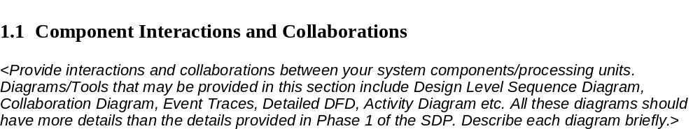handling.
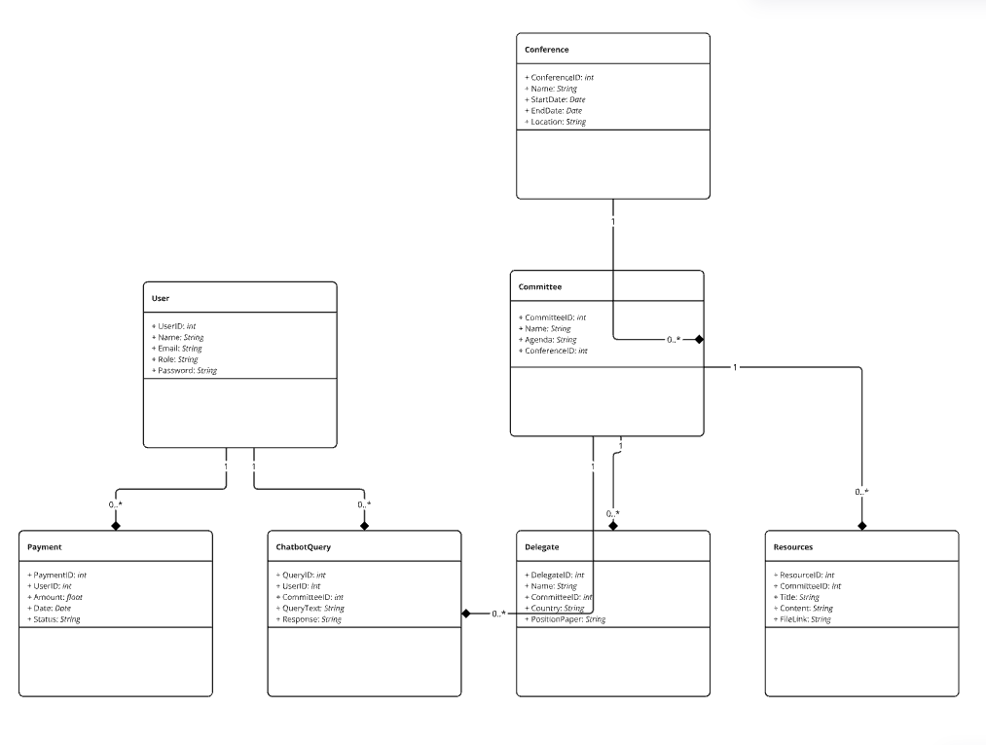

Component Interactions and Collaborations
The PREP-MUN application consists of multiple components that interact with each other to provide a seamless and efficient experience for Model United Nations participants. These interactions ensure that data flows smoothly between the frontend, backend, database, and external services. The system follows a layered architecture where each component has a defined role in processing requests, managing data, and delivering responses.
- System Interactions Overview
- User Interaction with UI (Frontend): Users (delegates, chairs, organizers) interact with the mobile or web application to perform actions such as registering for events, making payments, and accessing resources. The UI captures these inputs and sends them to the backend.
- Backend Processing: The backend services, hosted on Firebase Cloud Functions, process user requests and interact with the database. Business logic such as authentication, event registration, chatbot queries, and payment verification is handled at this stage.
- Database Interaction: The backend communicates with Firebase Firestore and Cloud Storage to fetch and store structured data (e.g., user profiles, event details, transaction logs).
- External Service Integrations: Third-party APIs like Stripe/PayPal for payments, Google OAuth for authentication, and OpenAI for the chatbot handle specific functionalities outside the core system.
- Notification System: Firebase Cloud Messaging (FCM) pushes real-time updates, such as event reminders and payment confirmations, to user
- Diagrams and Descriptions
- 1. Design-Level Sequence Diagram
The sequence diagram illustrates the step-by-step interaction between a delegate, the frontend, the backend, and the database when a user registers for an MUN conference.
- Step 1: The user selects a conference and enters details.
- Step 2: The frontend sends the registration request to the backend.
- Step 3: The backend validates user data and checks for availability in the Firestore database.
- Step 4: If registration is open, the backend processes the request and stores the information.
- Step 5: The payment gateway is called to handle the transaction.
- Step 6: Upon successful payment, a confirmation is sent to the user, and Firebase Cloud Messaging pushes a notification.
This diagram ensures that all system components are synchronized for real-time event registration.

- 2. Collaboration Diagram
The collaboration diagram represents the relationship between system components and their roles in handling MUN operations.
- Actors: Users (delegates, chairs, organizers) interact with the system.
- Objects: Event management, registration module, chatbot service, payment gateway, and database storage.
- Message Flow: The system ensures that data flows correctly between users, backend logic, and external APIs.
This diagram helps in visualizing the message exchange between various components, ensuring proper coordination.

- 3. Event Traces
An event trace outlines the interactions over time when an action is performed. For example, when a chair assigns a delegate to a committee, the system follows these steps:
- Trigger: The chair selects a delegate and assigns them a country or portfolio.
- Action: The system updates the delegate's status in the Firestore database.
- Notification: The assigned delegate receives a push notification about their assignment.
This trace ensures that committee assignments are updated instantly and that users receive real-time information.

- 4. Detailed Data Flow Diagram (DFD)
The DFD represents how data moves through the PREP-MUN system.
- Level 0 (Context Diagram): Shows the overall system with users (delegates, chairs, organizers) interacting with PREP-MUN.
- Level 1 (Detailed DFD):
  - User Authentication: Users log in via Firebase Authentication.
  - Conference Registration: User data is sent to the backend and stored in Firestore.
  - Chatbot Queries: User queries are processed via OpenAI API and stored for future training.
  - Payment Processing: The payment request is validated and recorded.
This detailed breakdown ensures data integrity and seamless transaction handling.

- 5. Activity Diagram
The activity diagram represents the workflow for event registration:
- The user logs into the system.
- The system verifies authentication and role-based access.
- The user selects an MUN conference and submits registration.
- Payment is processed, and the system updates the user's status.
- The confirmation message is displayed, and a notification is sent.
This diagram helps visualize the decision-making flow in the system, ensuring smooth user navigation.

Technology Architecture
The PREP-MUN application is built on a scalable, cloud-based technology architecture that ensures real-time communication, secure transactions, and high availability. The system is designed using a multi-tiered architecture, consisting of the frontend (user interface), backend (business logic and APIs), database (data storage and retrieval), and external integrations such as payment gateways, chatbot APIs, and cloud messaging services. The infrastructure ensures that all system components work seamlessly while maintaining security, performance, and accessibility.
The application is developed using modern, cross-platform technologies to ensure compatibility across multiple devices and operating systems. The frontend is built using Flutter (Dart) for cross-platform mobile compatibility (Android) and React.js for the web-based admin panel. The backend is implemented using Node.js on Firebase Cloud Functions, ensuring a serverless, scalable environment. The database and storage use Firebase Firestore (NoSQL Database) for structured data storage and Firebase Cloud Storage for managing documents such as position papers, MUN guidelines, and user files.
The application is hosted on Google Firebase, providing a serverless architecture that ensures automatic scaling, high availability, and reduced maintenance costs. Firebase Hosting is used for serving static content and web interfaces, while Firebase Cloud Functions manage backend logic, including authentication, data retrieval, and chatbot interactions.
Connectivity requirements include reliable internet access, as the application relies on cloud services for real-time updates, authentication, and chatbot functionality. The system supports both Wi-Fi and mobile data networks, ensuring accessibility for users in different locations. The application also implements offline storage capabilities using Firestore's caching mechanism, allowing users to access previously loaded data without an active internet connection.
The application operates in multiple modes, including mobile, web, and administrative interfaces. Mobile users interact with the application via the Flutter-based interface, while organizers and chairs use the React-based web dashboard for event management. The system runs in a cloud-based environment, ensuring real-time synchronization between different user roles and devices. The chatbot operates in an asynchronous mode, processing user queries and providing instant responses. Push notifications, powered by Firebase Cloud Messaging, ensure that users receive updates about schedule changes, committee assignments, and other critical information.
Security is a critical aspect of the technology architecture. The system employs end-to-end encryption for sensitive data, ensuring secure authentication and transaction processing. Firebase Authentication provides multi-factor authentication options, while role-based access controls restrict certain functionalities based on user roles. Data is securely stored in Firestore with access rules defined through Firebase Security Rules, ensuring that only authorized users can view or modify specific data.
Scalability is a key consideration, with Firebase's auto-scaling infrastructure ensuring that the system can handle large numbers of concurrent users during major MUN events. The application is designed to efficiently manage increasing data loads, optimizing performance while maintaining cost-effectiveness. The chatbot system integrates with machine learning models, allowing continuous improvements based on user interactions.

Architecture Evaluation
- 6.4 Architecture Evaluation
The selection of infrastructure and technology for the PREP-MUN application was driven by the need for scalability, real-time updates, ease of development, and security. Firebase was chosen as the backend infrastructure due to its serverless architecture, automatic scaling, and real-time database capabilities. Given the nature of MUN events, which require frequent updates, instant notifications, and dynamic data handling, Firebase's Firestore database was a suitable choice as it provides real-time synchronization without requiring complex server management. Cloud Functions were used to handle backend logic, reducing the need for dedicated server maintenance while ensuring that authentication, event registration, and chatbot services operate efficiently.
Flutter was selected as the frontend framework due to its ability to develop cross-platform applications with a single codebase, ensuring consistent performance across both Android and iOS devices. The alternative approach of using native development for Android (Java/Kotlin) and iOS (Swift) was considered, but it would have increased development time and maintenance overhead. React.js was chosen for the web-based admin panel because of its component-based architecture, making it easier to maintain and scale.
For chatbot implementation, OpenAI’s GPT API was selected overrule-based chatbot solutions due to its ability to handle complex user queries with contextual awareness. Rule-based chatbots, while structured and predictable, lacked the flexibility required for diverse MUN-related questions, which often require detailed responses and adaptability. The decision to integrate Stripe and PayPal for payments was based on their global acceptance, ease of API integration, and compliance with security standards such as PCI-DSS.
One of the advantages of the selected architecture is its ability to scale without requiring additional server management, as Firebase handles load balancing and infrastructure scaling automatically. The integration of Firebase Cloud Messaging ensures that users receive real-time updates, which is critical for event notifications and schedule changes. Additionally, Flutter’s single codebase reduces development effort and provides a smooth user experience on different platforms.
Despite these advantages, the chosen infrastructure has some drawbacks. Firebase, while efficient for real-time applications, has limitations when handling complex queries compared to traditional SQL databases. The cost of Firebase services may also increase as the user base grows, making it necessary to monitor usage and optimize data reads and writes. Flutter, although powerful, has a slightly larger app size compared to native applications, which may impact users with limited storage space.
Alternative technologies such as AWS Amplify, or a custom backend built on Node.js and Express with a PostgreSQL database were considered but were not chosen due to their higher development and maintenance overhead. AWS Amplify offers similar backend functionalities but requires additional configuration and a learning curve. A custom backend using Node.js with a SQL database would provide more control over data handling but would demand additional server maintenance and infrastructure costs.
The selected architecture provides an optimal balance of performance, scalability, and ease of development. It ensures that PREP-MUN can handle real-time updates, secure transactions, and user interactions efficiently while minimizing infrastructure maintenance. The combination of Firebase, Flutter, and OpenAI's GPT API supports a feature-rich, interactive experience for MUN participants, making the system reliable, scalable, and user-friendly.

Detailed Design and Implementation
<In this section provide details of the types of interactions and collaborations in your project. Also elaborate the interactions already described in section 2.2. Tools such as deployment diagram, class diagram (complete in all aspects), database schema, design level sequence diagram, state diagram, petrinets etc. may be used to provide all the details. Any design principles being followed during the projects may be mentioned and described in this section.>

Component-Component Interface
Mobile App (Flutter): The client-facing application where users interact with the app's features.
Backend Services (Firebase Functions): Handles server-side logic, user authentication, and communication with other components.

Database (Firestore/Storage): Stores user data, resources, and other app-related information.

AI Chatbot (OpenAI GPT): Processes user queries related to committees and topics.

Admin Portal: Manages administrative tasks, such as conference details, user queries, and updates.

Hosting Platform (Google Firebase): Hosts backend services and database for the app.

Component-External Entities Interface
The PREP-MUN application interacts with multiple external entities to facilitate functionalities such as authentication, payment processing, AI-driven chatbot services, and real-time notifications. These external integrations ensure that the system operates efficiently, securely, and in compliance with industry standards.
The system communicates with Firebase Authentication for user verification, allowing delegates, chairs, and organizers to log in using email, Google authentication, or other third-party login providers. This eliminates the need for managing custom authentication logic while ensuring secure access control.
For payment processing, the system integrates with third-party payment gateways such as Stripe and PayPal to handle conference registration fees. When a user initiates a payment, the request is sent to the payment service provider, which processes the transaction, verifies payment details, and returns a success or failure response to the system. This ensures that financial transactions are conducted securely and comply with PCI-DSS regulations.
The AI-powered chatbot uses the OpenAI GPT API to provide intelligent query handling for delegates seeking guidance on MUN procedures, committee rules, or event-related queries. User messages are sent to the chatbot API, which processes the request and returns an appropriate response. The chatbot does not store sensitive user information, ensuring data privacy.
For notifications and real-time updates, Firebase Cloud Messaging (FCM) is used to send push notifications to users about schedule changes, committee assignments, payment confirmations, and event announcements. The backend communicates with the FCM service, which delivers the message to the respective user’s mobile or web application.
The system architecture also allows for potential future integrations with national identity verification systems such as NADRA for identity authentication, ensuring that only verified individuals participate in sensitive MUN discussions. While this feature is not currently implemented, the architecture is designed to support such integrations if required.
An external API interaction diagram can be used to illustrate these communications, where user actions trigger requests to the backend, which then interacts with various third-party services before returning a response to the user interface. This ensures a seamless experience where external entities handle specialized tasks such as authentication, payment verification, and chatbot interactions while PREP-MUN focuses on event management and user experience.

Component-Human Interface
The Component-Human Interface in the MUN mobile app bridges user interactions with system components, providing an intuitive and efficient experience for various stakeholders, including delegates, organizers, and chairs. Key details include:

User Interface (UI):
- Design Tools: The UI is designed using Figma, focusing on modern, user-friendly, and accessible layouts that cater to both experienced and novice users.
- Features:
  - Navigation: Intuitive menu systems for easy access to features like committee details, resources, and chatbot queries.
  - Customizable Notifications: Users can set preferences for updates related to their committees or conference schedules.
  - Dashboard: A personalized dashboard displays key updates, schedules, and tasks for delegates.

Input Mechanisms:
- Touch-Based Interaction: Users interact with the app using touch gestures for seamless navigation and operation.
- Forms: Delegates use forms for registration, payment, and submission of position papers.

Output Mechanisms:
- Real-Time Updates: Push notifications (via Firebase Cloud Messaging) keep users informed about announcements, schedule changes, and important reminders.
- Dynamic Content Display: Information like committee agendas, conference details, and resources are dynamically fetched and displayed.

User Roles and Personalization:
- Delegates: Access study resources, submit papers, and query the chatbot for agenda-specific information.
- Organizers: Manage registrations, schedules, and conference updates via administrative tools.
- Chairs: Track delegate progress and manage committee proceedings directly through the app.

Accessibility Features:
- Responsive Design: The app supports devices with various screen sizes for accessibility.
- Inclusive Features: Options like text resizing, dark mode, and text-to-speech aim to enhance usability for diverse users.
By seamlessly integrating user needs with system functionality, the Component-Human Interface ensures a smooth and engaging MUN experience for all participants.

Screenshots/Prototype
<This complete section should be an improved version of the section presented in previous phases>

Workflow:
The workflow of the MUN mobile app is structured to streamline user interactions and facilitate core functionalities effectively. Here's an explanation of how different user actions and system components interact based on the given details:

User Registration and Authentication:
Users (delegates, chairs, or organizers) open the app and navigate to the registration or login screen.
Firebase Authentication validates user credentials (email and password). New users can create accounts with role-based access (Delegate, Organizer, Chair).
Upon successful authentication, users are redirected to their personalized dashboards.

Conference and Committee Management:
Organizers create or manage conferences by providing details like name, dates, and locations. Committees and agendas are added under specific conferences.
Delegates view available conferences and register for specific committees. Their registration details are stored in Cloud Firestore.

Resource and Agenda Access:
Delegates access curated study materials, such as agenda guides, country profiles, and MUN procedures, linked to their committees. These resources are fetched dynamically from Firebase.

Chatbot Query Resolution:
Delegates interact with the AI-powered chatbot to ask agenda-specific or procedural questions.
The chatbot processes queries, fetches relevant information from the database, and responds. All queries and responses are logged for reference.

Payment and Notifications:
Users make payments for conference registrations through the app, integrated with secure payment gateways. Payment statuses are updated in real-time.
Notifications are sent via Firebase Cloud Messaging to inform users about payment confirmations, schedule updates, or other critical announcements.

Real-Time Conference Updates:
Organizers push real-time updates, including schedule changes, announcements, and voting results, to registered delegates and chairs.
Delegates receive these updates as notifications and can access the information in the app's dashboard.

Position Paper Submission:
Delegates upload their position papers through the app. These are linked to their respective committees and stored in the backend for chairs to review.

Post-Conference Feedback and Resources:
After the conference, users can provide feedback through in-app forms.
Organizers upload post-conference resources, such as awards, minutes of proceedings, and delegate reports, for delegates to access.

Workflow Visualization
The app workflow integrates multiple system components (authentication, chatbot, resource management, notifications, and payment processing) to deliver a seamless and efficient user experience. This modular approach ensures flexibility, scalability, and clarity at every stage of interaction.

Screens:

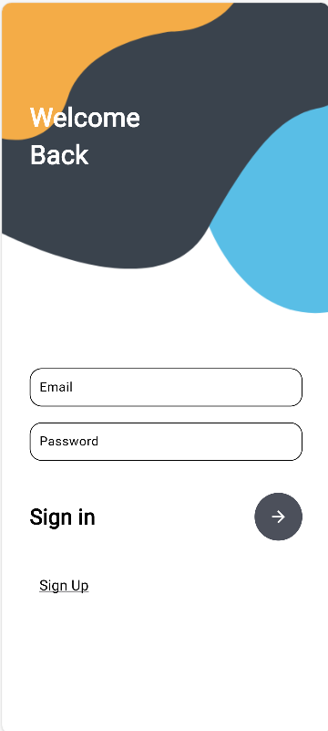

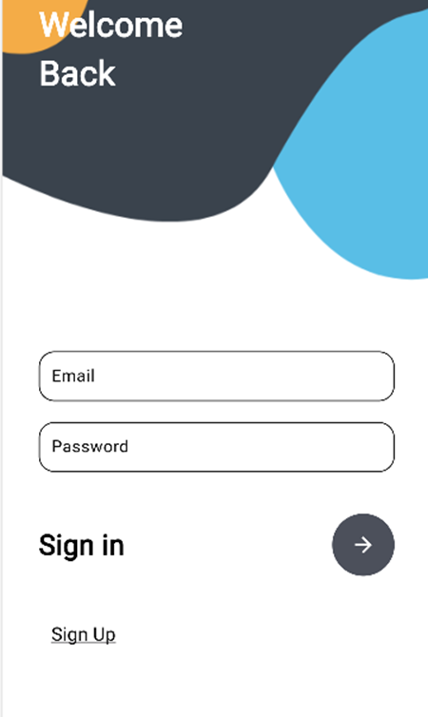

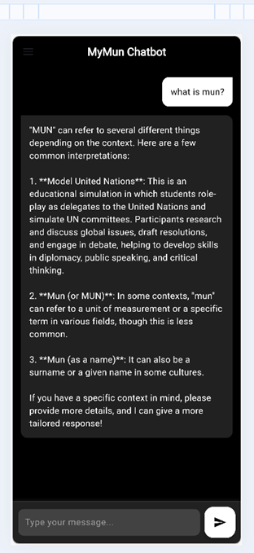

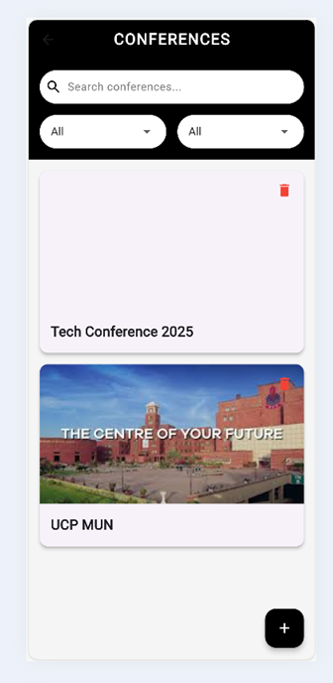

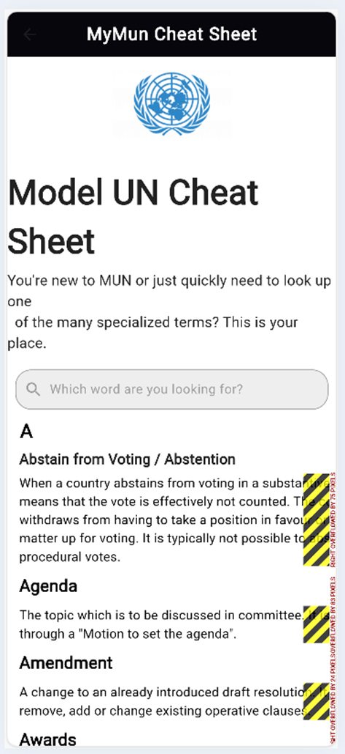

Additional Information
This app will be responsible for registering, paying and prep-ing for MUNs all over Pakistan.

Other Design Details
Resource Management for Conferences
Plan how resources like study guides, agendas, and country profiles will be managed and updated within the app.
Delegate Registration Process
Refine the flow for delegate registrations, ensuring a smooth and secure authentication system using Firebase.
Push Notification Implementation
Discuss the use of Firebase Cloud Messaging for timely updates on conferences, agendas, and other critical notifications.
Database Optimization and Scalability
Evaluate database architecture for efficiency in handling increasing user data and ensure scalability for future expansions.
Post-Launch Support Plan
Design a framework for post-deployment user support, including FAQ sections, chatbot assistance, and feedback handling.
Monetization and Revenue Streams
Explore options like premium features, advertising, and partnerships to ensure sustainable revenue generation for the app.
Educational Resource Curation
Discuss strategies for curating high-quality educational resources that cater to both novice and experienced MUN participants.

Test Specification and Results

Test Case Specification

Table 6.1: TC-1
Identifier | TC-1
Related requirements(s)
  UC-1 (User Registration)
Short description | Ensures that a user can successfully create an account using valid credentials
Pre-condition(s) | The user must not have an existing registered account. An internet connection is required.
Input data | Name, Email, Password, Role Selection (Delegate, Chair, Organizer)
Detailed steps | 1. Open the application and select "Sign Up"  2. Enter valid user credentials  3. Click on "Register"  4. System sends an OTP to verify email  5. Enter OTP and confirm registration
Expected result(s) | The system creates a new account, logs in the user, and redirects to the dashboard.
Post-condition(s) | The user account is successfully stored in the database and can be used for future logins
Actual result(s) | PASS
Test Case Result | PASS

Summary of Test Results

Table 6.2: Summary of All Test Results
Module Name | Test cases run | Number of defects found | Number of defects corrected so far | Number of defects still need to be corrected
Module 1 (for example Bill Calculation Module, Speech Processing Unit | REGISTRATION | 0 | 0 | 0
Module 2 | CHATBOT | 1 | 2 | 1
Module 3 | DOCUMENT | 0 | 2 | 0
Module 4 | CONFERENCE | 3 | 3 | 0
Module 5 | PAYMENT | 0 | 0 | 0
Module 6 | INFO | 1 | 1 | 1
Module 7 | EXPERIENCE | 2 | 2 | 0
Module 8 | POSITION PAPER | 1 | 1 | 0
Complete System | <Sum all of the above> | 8 | 11 | 2

Project Completion Status/Conclusion
The PREP-MUN application has made significant progress toward its planned objectives. The core functionalities, including user authentication, conference registration, payment processing, chatbot interaction, and real-time notifications, have been successfully implemented. The project has adhered to the proposed timeline, with most modules fully completed. A few minor enhancements, such as chatbot multilingual support and additional data analytics, remain as potential future improvements.
Table 7.1: Project Completion Status
Module Name | Status  (Complete, Partially Implemented, Not Implemented)
Module 1 (for example Bill Calculation Module, Speech Processing Unit
  Chatbot Interaction | Partially Implemented
  Notification System | Completed
  Report Generation | Partially Implemented
  Complete System | Completed
Module 2
  Conference Management | Completed
Module 3
  User Authentication | Completed
Complete System
  Payment Processing | Completed

Table 7.2: Objective(s)/Target(s) Status
Target/Objective | Status  (Completed,  Partially Completed,  Not Completed) | Reason(s)
Objective 1 |  | Fully implemented with Firebase authentication
  Delegate Registration System | Completed
Objective 2 | Conference Resource Management
  Completed
…
Number of Targets Completed | Notifications for Updates | Real-time notifications via Firebase Cloud Messaging
Number of Targets Partially Completed | Basic chatbot implemented, multilingual support still in progress | Study guides, position paper templates, and rules uploaded
Number of Targets Not Completed |  | Basic payment system integrated, but sponsorship options are pending
  Monetization Strategy

References
www.mymun.com
www.harvardmun.com

Appendix A Glossary
TC: Test Case
UC: Use Case

Appendix B IV & V Report
(Independent verification & validation)
IV & V Resource

Name Signature

S# | Defect Description | Origin Stage | Status | Fix Time
 |  |  |  | Hours | Minutes
1
2
3
…
Table B.2: List of non-trivial defects

Deployment/Installation Guide
The PREP-MUN app is available on the Google Play Store and Apple App Store. Users can download, install, and sign-up using email or Google accounts. The web version is accessible via a browser for event management and interactions.
For local deployment, clone the repository, install dependencies, configure Firebase, and run the backend and frontend. The app can be deployed by building the APK for Android, submitting the iOS build to the App Store, and hosting the web version on Firebase.

User Manual
The PREP-MUN app allows users to register, participate in conferences, and access resources.
To sign up, open the app or web portal, enter your email, password, and role, then verify your account. To register for a conference, log in, select an event, choose a committee, and complete payment. The chatbot assists with MUN rules and queries. Notifications keep users updated on schedules and announcements.
Organizers can create and manage events through the web dashboard. Chairs can review delegate assignments and position papers. Delegates can access study materials and interact with other participants

